You are given the head of a linked list. **Delete** the **middle node**, and return *the* head *of the modified linked list*.

The **middle node** of a linked list of size n is the ⌊n / 2⌋th node from the **start** using **0-based indexing**, where ⌊x⌋ denotes the largest integer less than or equal to x.

* For n = 1, 2, 3, 4, and 5, the middle nodes are 0, 1, 1, 2, and 2, respectively.

**Example 1:**

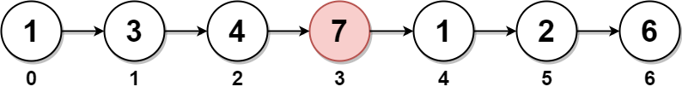

**Input:** head = [1,3,4,7,1,2,6]

**Output:** [1,3,4,1,2,6]

**Explanation:**

The above figure represents the given linked list. The indices of the nodes are written below.

Since n = 7, node 3 with value 7 is the middle node, which is marked in red.

We return the new list after removing this node.

**Example 2:**

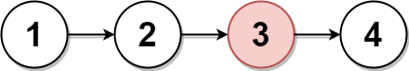

**Input:** head = [1,2,3,4]

**Output:** [1,2,4]

**Explanation:**

The above figure represents the given linked list.

For n = 4, node 2 with value 3 is the middle node, which is marked in red.

**Example 3:**

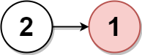

**Input:** head = [2,1]

**Output:** [2]

**Explanation:**

The above figure represents the given linked list.

For n = 2, node 1 with value 1 is the middle node, which is marked in red.

Node 0 with value 2 is the only node remaining after removing node 1.

**Constraints:**

* The number of nodes in the list is in the range [1, 105].
* 1 <= Node.val <= 105